**Topic:**

***Power BI Dashboard - Instant E -Commerce Analysis***

**Overview:**

This power BE dashboard presents insight into e-commerce sales in various cities and platforms.

This highlights revenue trends, order volumes and platform-wise performance, enabling strategic decisions for city-specific development.

**Objective:**

• Analyze performance in major cities

• Compare sales in e-commerce platforms

• Identify trends and opportunities for adaptation

**Equipment and Technologies:**

*Power BI, Excel, DX, Data Modeling*

**The main features of the dashboard:**

* Interactive slices for the city and stage.
* Dynamic filter and drill-down capabilities.
* Views for Total Sales KPI, Average Order Price.
* Bar and line charts for monthly and category trends.

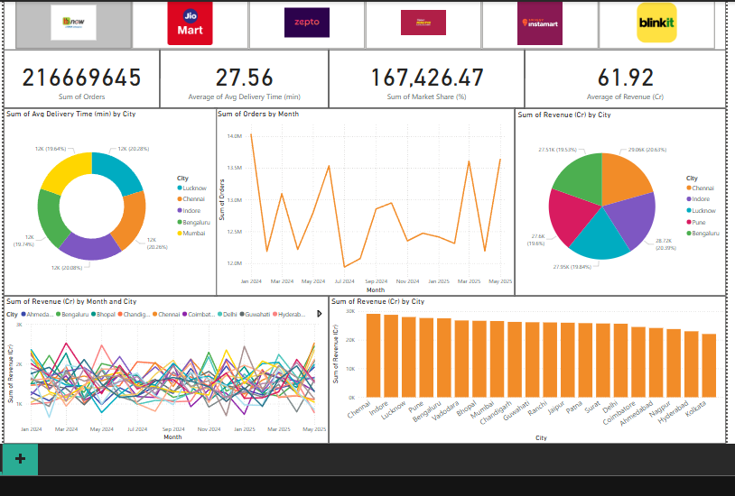**Screenshots:**